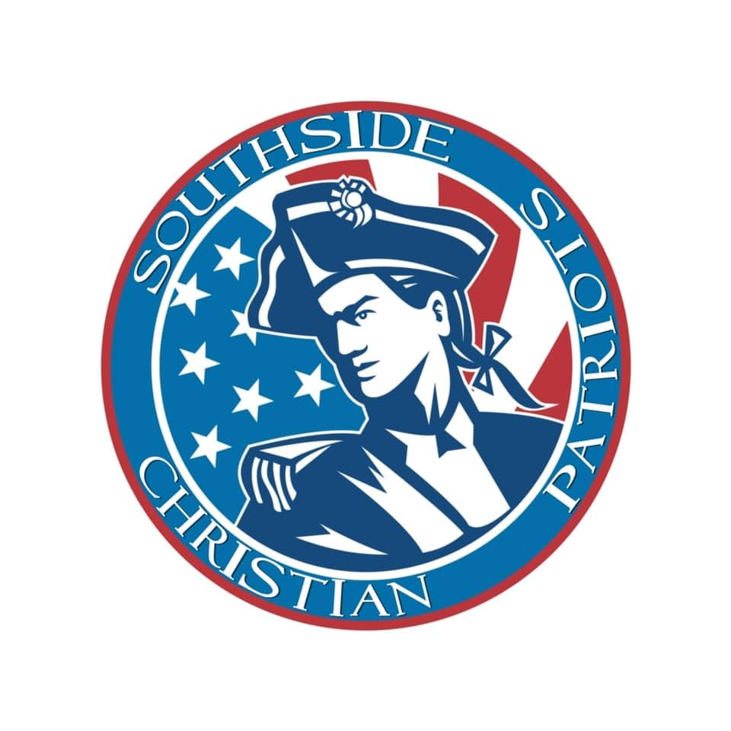

SPONSOR TODAY

All items from previous levels
Large placard on Patriot Sponsor Board
One ½ page yearbook ad
1 Additional SCS t-shirt
Year end awards ceremony sponsor
All items from previous levels
Small placard on Patriot Sponsor Board
One ¼ page yearbook ad
Family pack of tickets to one Southside Players Production
Special mention at banquets
All items from previous levels
2 Patriot Season Passes to all home, athletic events (not including tournaments)
Social Media Saturday Spotlight
Business flyer distribution
1 SCS tumbler
All items from previous levels
1 SCS T-shirt
Social Media representation
Website representation
Letter of appreciation
Platinum Sponsorship Package $3000
Bronze Sponsorship Package $250
Gold Sponsorship Package $1000
Silver Sponsorship Package $500

Current needs include:
Covered walkway
Outdoor Seating/ Picnic Tables
Rack for Chromebooks
Digital aids
Training
Improved Internet
Outside restroom facilities

ACADEMIC SPONSORSHIP PACKAGES
For assistance with sponsorship,
contact Monica Youngblood, our Administrator, at administrator@southsidek12.com

or call 912-285-5438

ACADEMIC SPONSORSHIP PACKAGES

Business Name ______________________________________________________________________
Address______________________________________________________________________________
City _____________________________________ Zip _______________________________________
Do you have a child/family member that attends Southside? ___ Yes ___ No
What is their name?__________________________________________________________________
I AM PROUD TO BECOME A PATRIOT SPONSOR!

Signature____________________________________________________________________________
Print Name __________________________________________________________________________
Date _________________________________________________________________________________

Please select your Sponsorship Package below by marking the appropriate box.
All items from previous levels
Large placard on Patriot Sponsor Board
One ½ page yearbook ad
1 additional SCS t-shirts
Year end awards ceremony sponsor
All items from previous levels
Small placard on Patriot Sponsor Board
One ¼ page yearbook ad
Family pack of tickets to one Southside Players Production
Special mention at banquets
All items from previous levels
2 Patriot Season Passes to all home, athletic events (not including tournaments)
Social Media Saturday Spotlight
Business flyer distribution
1 SCS tumbler
All items from previous levels
1 SCS T-shirt
Social Media representation
Website representation
Letter of appreciation
Platinum Sponsorship Package $3000
Bronze Sponsorship Package $250
Gold Sponsorship Package $1000
Silver Sponsorship Package $500

